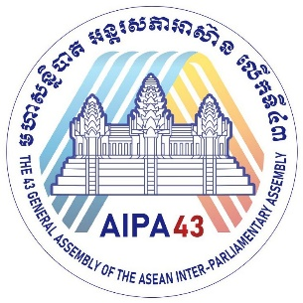


The 43rd General Assembly
of the ASEAN Inter-Parliamentary Assembly (AIPA)

20-25 November 2022
Phnom Penh, Kingdom of Cambodia
Advancing Together for Sustainable, Inclusive and Resilient ASEAN

FLIGHT AND HOTEL INFORMATION: (COUNTRY NAME)
Created on: ……………………….

No. | Name | Composition of Delegation | Position | Passport Number |  | Date | Time | Flight Number | Hotel
1 |  |  |  |  | Arrival:
 |  |  |  |  | Departure:
2 |  |  |  |  | Arrival:
 |  |  |  |  | Departure:
3 |  |  |  |  | Arrival:
 |  |  |  |  | Departure:
4 |  |  |  |  | Arrival:
 |  |  |  |  | Departure:
5 |  |  |  |  | Arrival:
 |  |  |  |  | Departure:
6 |  |  |  |  | Arrival:
 |  |  |  |  | Departure:
7 |  |  |  |  | Arrival:
 |  |  |  |  | Departure:
8 |  |  |  |  | Arrival:
 |  |  |  |  | Departure:
9 |  |  |  |  | Arrival:
 |  |  |  |  | Departure:
10 |  |  |  |  | Arrival:
 |  |  |  |  | Departure:
11 |  |  |  |  | Arrival:
 |  |  |  |  | Departure:
12 |  |  |  |  | Arrival:
 |  |  |  |  | Departure:
13 |  |  |  |  | Arrival:
 |  |  |  |  | Departure:
14 |  |  |  |  | Arrival:
 |  |  |  |  | Departure:
15 |  |  |  |  | Arrival:
 |  |  |  |  | Departure:
16 |  |  |  |  | Arrival:
 |  |  |  |  | Departure:
17 |  |  |  |  | Arrival:
 |  |  |  |  | Departure:

